Press Release

**may 16th – june 13th | PANDOLFINI WITH ASSOCIAZIONE ARTE CONTINUA:**

charity auction for urban reforestation



Pandolfini is pleased to actively collaborate with the **Associazione Arte Continua** for the organization of the **CHARITY AUCTION FOR URBAN REFORESTATION**, a sale that will only be online on the **PANDOLFINI LIVE platform from May the 16th until June the 13th 2022.**

Pandolfini is confident that the sale of the **32 lots**, on which will not be applied any other fees, will be once again the result of the great generosity of contemporary art lovers and **collectors** who follow the sales of the department with diligence and of all those who who care about the good and the **future of the earth**.

A project realized and organized by Associazione Arte Continua, along with Stefano Mancuso, PNAT, and the Comune of Prato to which, as part of the **Prato Forest City project, the proceeds for the urban reforestation of the Tobbiana-Allende neighborhoods will be donated by planting 300 trees**.

B", which together with that of plants, is essential for the very existence of human life and our planet. It is on these assumptions that 12 Italian and international artists have kindly offered the works that will be auctioned by Pandolfini: **Maria Thereza Alves, Per Barclay, Loris Cecchini, Jimmie Durham, Alberto Garutti, Carsten Höller, Pascale Marthine Tayou, Cildo Meireles , Giovanni Ozzola, Tobias Rehberger, Kiki Smith, Nari Ward and Massimo Bartolini.**

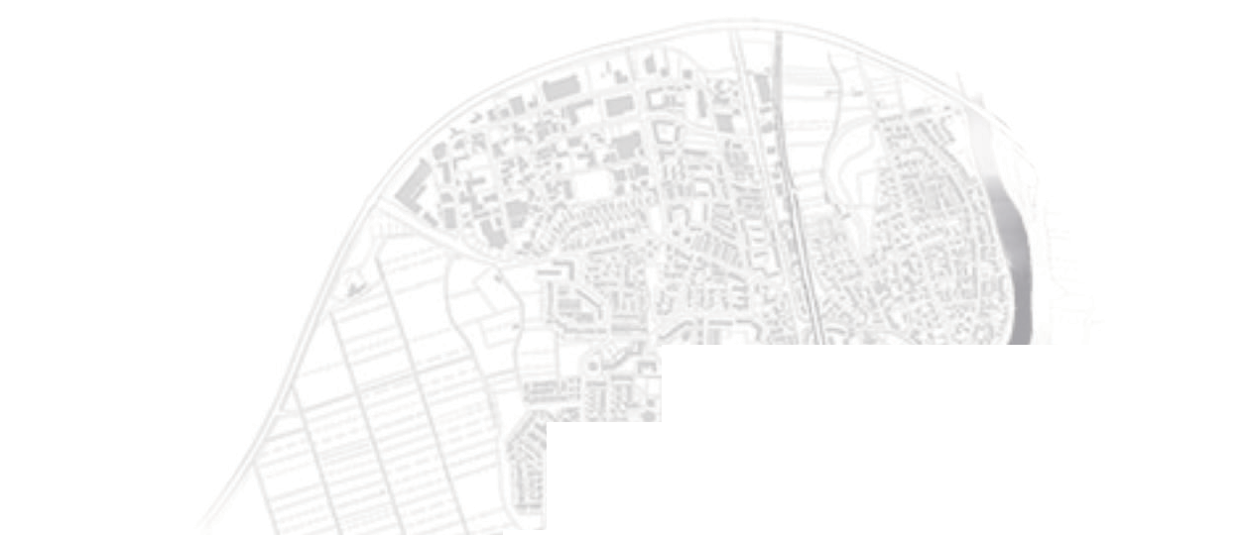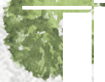



*Contact Pandolfini Casa d’Aste*

**Press Office | Anna Orsi**

annaorsi.press@pandolfini.it | anna.orsi@pressart.eu | cell. 335 6783927

**Dipartimento Arte Moderna e Contemporanea**

artecontemporanea@pandolfini.it | tel. 055 23 40 888

**Associazione Arte Continua**

[info@artecontinua.org](mailto:info@artecontinua.org) | tel. 0577 907157

inquiry@artecontinua.org